Question of the Day / Bible Story / Memory Verse
Lead to Large Group at 9:10/11:10

Classroom Management Idea: Sit with your few during Large Group. If they see you paying attention and into the lesson they will want to pay attention as well.

*First Time Guests: If you have any first time guests who seem a little shy, pair them up with one of the regular attenders. This will help them feel like part of the group and less stressed about not knowing one of the answers during the different activities.

Questions:
- Have you ever used a Map? When and why did you use it?

Memory Verse Activity:
What You Need: Memory Verse Sheet
What You Do:
- Review the memory verse a few times as a group
- If the motions help your group learn the verse go over them a few times. If the motions tend to cause issues just review the verse a few times and move on to the game.

Application Activity: “Book of the Bible”
What You Need: (1 per group) Books of the Bible Sheets, Leader Books of the Bible Sheet, Books of the Bible Keyring, and timer (or cellphone)  What You Do and Say:  - Review the Books of the Bible using the leader sheet and Key Ring  - Pass out the Books of the Bible sheets (Book Names ONLY) but don’t allow the kids to look at the sheets until you say go.  - Place the Group names on the ground in order (Law / History / Poetry / Major Prophets / Minor Prophets / Gospels / History / Paul’s Letters / Prophecy)  - Explain the rules of the game:  - When I say “GO” you will WORK TOGETHER as a team to put the Books of the Bible in order and in the specific group. (Hint: Just like the sheet we used to review)  - When I say “GO” I will start the timer and we will see how quickly you can put the books in order as a team.  - When you’re done I will check your work to see if it’s correct. If it’s not you will have to work together as a team to figure out which Book is out of order.  Leaders: Try not to help the kids too much. If they are having a really hard time point them in the right direction without giving them the answer.  - Continue this game until the kids are no longer interested...You can also divide your group into teams and see which team can put the books in order the quickest for more of a challenge!  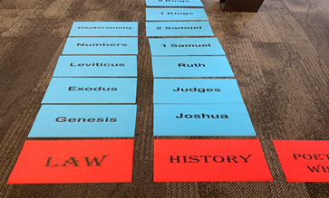 | 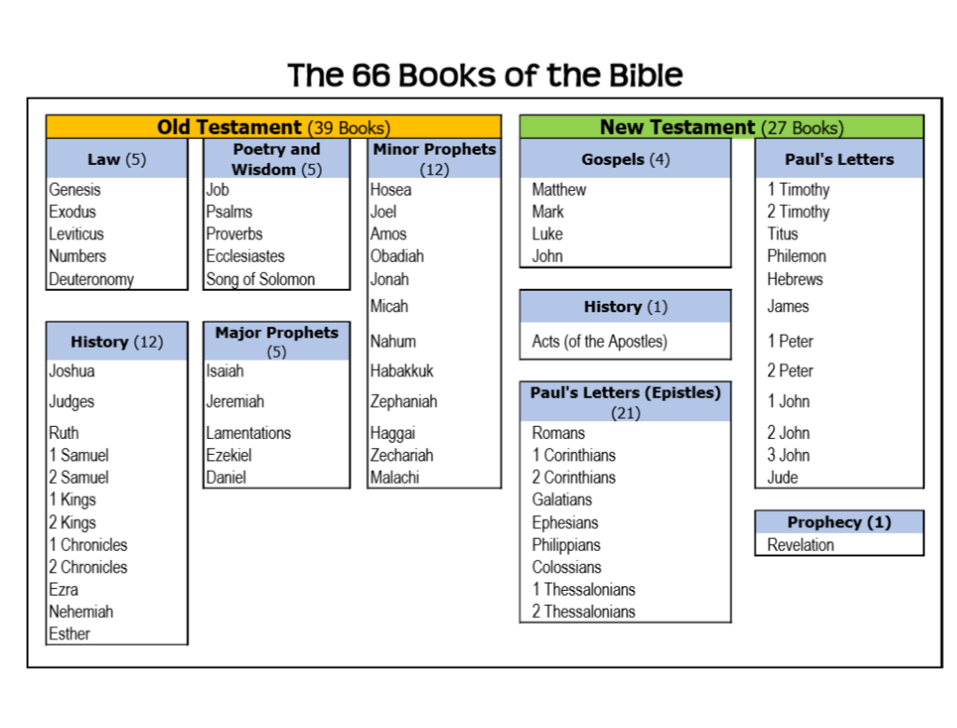  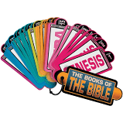

Prayer / Review Game
Closing Prayer:  What You Do:  - Ask for requests and jot them down.  - Follow up on last week’s prayers  - Say a prayer lifting up all prayer requests...Bonus points if a child would like to pray.  Review Game Idea:  Question Ideas: (Don’t be afraid to come up with your own questions)  - How long has Scott (in the beard) been waiting for the carnival to open? (weeks)  - What has Brandon been doing to prepare for the carnival? (saving his money)  - What happened to Scott the last time he ate too much at the carnival? (a bad stomach-ache)  - What did Brandon make to help them at the carnival? (a list of all the attractions  - How are the 39 books of the OT organized? ()Law, History, Poetry & Prophets)  - How are the 27 books of the NT organized? (Gospels, Acts, Letters & Revelation)  - What is the Bible? (It’s one big book that tells the story of God and what He has done for us)  - What did Brandon & Scott promise to bring to Kelli? (cotton candy)  - How is the carnival similar to the Bible (66 different books/ 66 attractions all in one)  - What things does Scott want to get deep fried? (a chocolate covered banana with peanuts on top; and other things)  - What’s the Bottom Line this week? The Bible has a map to help us find the stories of God.  - What was the FIRST thing the guys did? (Took a selfie) | 